DR. D. Y. PATIL SCHOOL OF MCA
Savitribai Phule Pune University
Master of Computer Applications (MCA)

SOFTWARE REQUIREMENTS SPECIFICATION (SRS)
Functional & Non-Functional Requirements, Use Cases & Activity Diagrams
HireHub: Premium Job Portal

Date: 18/03/2026
Submitted by: Mayur Vijay Shewale
Guide : Prof Sapna Chavan

SOFTWARE REQUIREMENTS SPECIFICATION (SRS)

1. Introduction

1.1 Purpose
This document describes the Software Requirements Specification for HireHub: Premium Job Portal, a full-stack web application designed to connect job seekers with employers through an intelligent and modern recruitment platform.

1.2 Scope
The system serves three user types: Job Seekers (search, apply, track), Employers (post, manage, assess), and Administrators (manage, monitor). The platform provides REST APIs consumed by the React frontend, with real-time features via WebSocket.

2. Functional Requirements

2.1 User Authentication (FR-1)

ID | Requirement | Priority
FR-1.1 | Users can register with email and password | Must
FR-1.2 | Users can login with email/password | Must
FR-1.3 | Users can login with Google OAuth2 | Should
FR-1.4 | JWT tokens expire after 24 hours | Must
FR-1.5 | Users can logout securely, clearing the session | Must
FR-1.6 | Password reset via email link | Should

2.2 User Profile Management (FR-2)

ID | Requirement | Priority
FR-2.1 | Job seekers can create and edit personal profile | Must
FR-2.2 | Employers can create and edit company profile | Must
FR-2.3 | Users can upload a profile picture | Should
FR-2.4 | Users can view other public user profiles | Should

2.3 Job Management (FR-3)

ID | Requirement | Priority
FR-3.1 | Employers can post new jobs with full details | Must
FR-3.2 | Employers can edit and delete their job postings | Must
FR-3.3 | Job seekers can search jobs with multiple filters | Must
FR-3.4 | Job seekers can save jobs for later review | Should
FR-3.5 | Jobs support filters: location, salary, type, experience | Must

2.4 Resume Management (FR-4)

ID | Requirement | Priority
FR-4.1 | Users can build resume using guided step-by-step builder | Must
FR-4.2 | Users can upload PDF resumes from their device | Must
FR-4.3 | System should analyse ATS compatibility and return score | Should
FR-4.4 | Users can manage multiple resumes and set a primary one | Must

2.5 Application Management (FR-5)

ID | Requirement | Priority
FR-5.1 | Job seekers can apply to jobs with a selected resume | Must
FR-5.2 | Job seekers can track their application status pipeline | Must
FR-5.3 | Employers can view all received applications per job | Must
FR-5.4 | Employers can update application status through pipeline | Must
FR-5.5 | System calculates AI match score for each application | Should
FR-5.6 | Kanban view for employer application pipeline management | Should

2.6 Messaging System (FR-6)

ID | Requirement | Priority
FR-6.1 | Users can send text messages to connected users | Must
FR-6.2 | Real-time message delivery via WebSocket (STOMP) | Must
FR-6.3 | Complete message history is preserved in database | Must
FR-6.4 | Users can only initiate messaging after an application exists | Must

2.7 Notification System (FR-7)

ID | Requirement | Priority
FR-7.1 | Users receive notifications for new messages | Must
FR-7.2 | Users receive notifications for application status changes | Must
FR-7.3 | Notifications are delivered in real-time via WebSocket | Must
FR-7.4 | Users can mark individual or all notifications as read | Must

2.8 Quiz System (FR-8)

ID | Requirement | Priority
FR-8.1 | Employers can create quizzes linked to job postings | Should
FR-8.2 | Employers can add multiple-choice questions to quizzes | Should
FR-8.3 | Job seekers can take assigned quizzes with time limits | Must
FR-8.4 | System calculates quiz scores automatically on submission | Must
FR-8.5 | Quiz results are visible to employers in the application view | Must

2.9 Interview Scheduling (FR-9)

ID | Requirement | Priority
FR-9.1 | Employers can schedule interviews for shortlisted candidates | Should
FR-9.2 | Job seekers can view their scheduled interview details | Must
FR-9.3 | Employers can mark interviews as complete with feedback | Should

2.10 Analytics & Dashboard (FR-10)

ID | Requirement | Priority
FR-10.1 | Dashboard shows key statistics (active jobs, applications, etc.) | Must
FR-10.2 | Charts display application trends and hiring pipeline data | Should
FR-10.3 | Employers can view company-specific job and applicant analytics | Should

3. Non-Functional Requirements

3.1 Performance

ID | Requirement | Metric
NFR-1.1 | Page load time | < 3 seconds
NFR-1.2 | API response time | < 500 ms
NFR-1.3 | Support concurrent users | 100+
NFR-1.4 | Database query time | < 200 ms

3.2 Scalability

ID | Requirement
NFR-2.1 | System should handle 10,000+ job postings without degradation
NFR-2.2 | System should support 1,000+ concurrent users at peak load

3.3 Security

ID | Requirement
NFR-3.1 | All passwords must be hashed using BCrypt before storage
NFR-3.2 | JWT tokens must be signed with HMAC-SHA256 secret
NFR-3.3 | All client-server communication must use HTTPS
NFR-3.4 | Role-based access control enforced at every API endpoint
NFR-3.5 | All user inputs must be validated and sanitised server-side

3.4 Reliability

ID | Requirement
NFR-4.1 | System uptime target: 99% or above
NFR-4.2 | Automated daily database backup
NFR-4.3 | Graceful error handling with meaningful error messages

3.5 Usability

ID | Requirement
NFR-5.1 | Responsive design that works on mobile, tablet, and desktop
NFR-5.2 | Dark mode and light mode support with user preference persistence
NFR-5.3 | Intuitive navigation with maximum 3-click access to core features
NFR-5.4 | Accessible colour contrast ratio (WCAG 2.1 AA standard)

3.6 Browser Compatibility

ID | Browser
NFR-6.1 | Google Chrome (latest stable version)
NFR-6.2 | Mozilla Firefox (latest stable version)
NFR-6.3 | Microsoft Edge (latest stable version)

Use Case Diagram

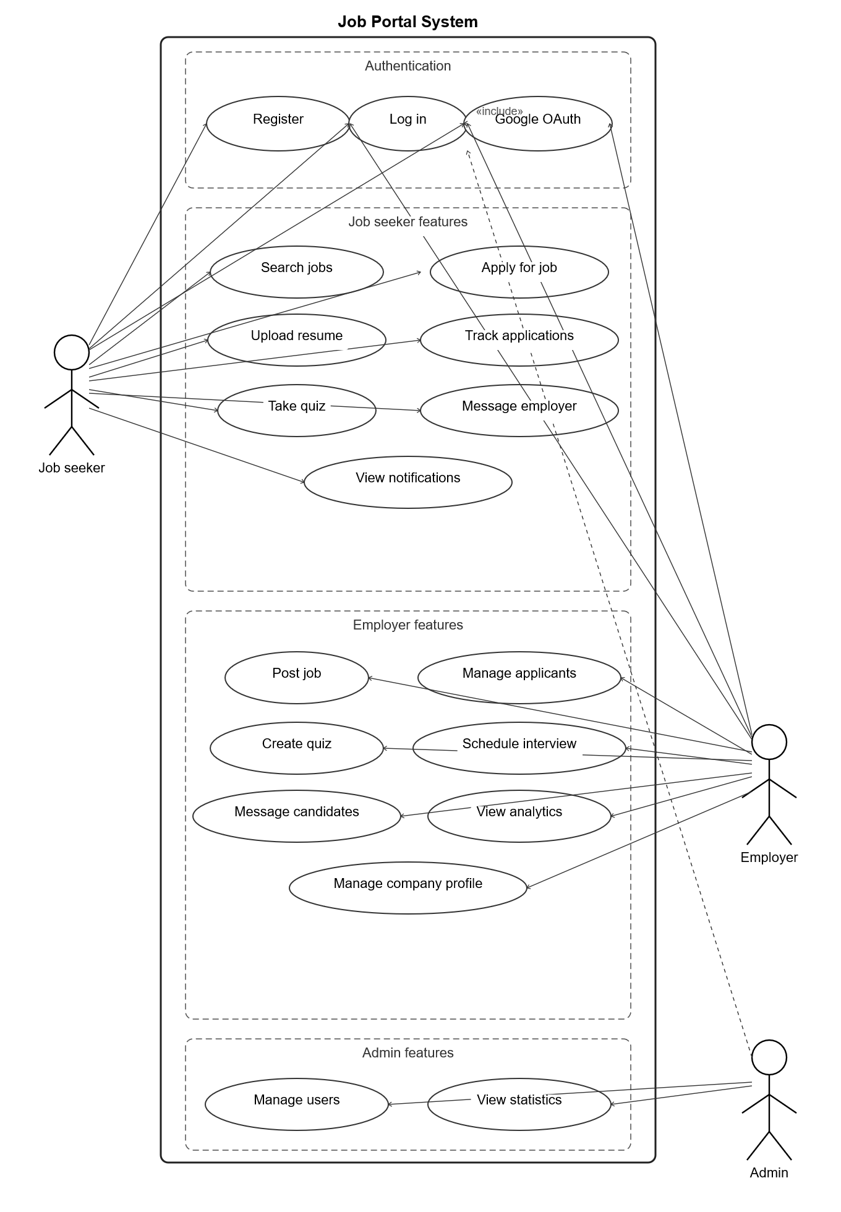
5. Use Case Descriptions

UC-1: User Registration
Actors: Job Seeker, Employer
Flow: (1) User clicks Register. (2) User selects account type (Job Seeker / Employer). (3) User enters email, password, and name. (4) System validates input fields. (5) System creates the user account in the database. (6) System sends a verification email. (7) User verifies email. (8) Account is activated and ready to use.

UC-2: Job Search and Application
Actors: Job Seeker
Flow: (1) User enters search criteria. (2) System displays matching job listings. (3) User selects a job and views details. (4) User selects a resume from their profile. (5) User submits the application. (6) System calculates the AI match score. (7) System sends a notification to the employer.

UC-3: Resume Building
Actors: Job Seeker
Flow: (1) User opens the Resume Builder. (2) User enters personal details. (3) User adds education entries. (4) User adds work experience. (5) User adds skills. (6) User adds projects and certifications. (7) System generates a downloadable PDF. (8) User saves the resume to their profile.

UC-4: Application Management
Actors: Employer
Flow: (1) Employer views received applications. (2) Employer filters by status or job. (3) Employer reviews candidate profile and resume. (4) Employer updates application status. (5) Employer schedules an interview. (6) System notifies the candidate of the status change.

UC-5: Real-time Messaging
Actors: Job Seeker, Employer
Flow: (1) User opens the chat interface. (2) System establishes a WebSocket (STOMP) connection. (3) User types and sends a message. (4) System delivers the message in real-time via the message broker. (5) Recipient receives the message instantly. (6) Message is saved to the database for history.

Activity Diagrams
Login Activity Diagram

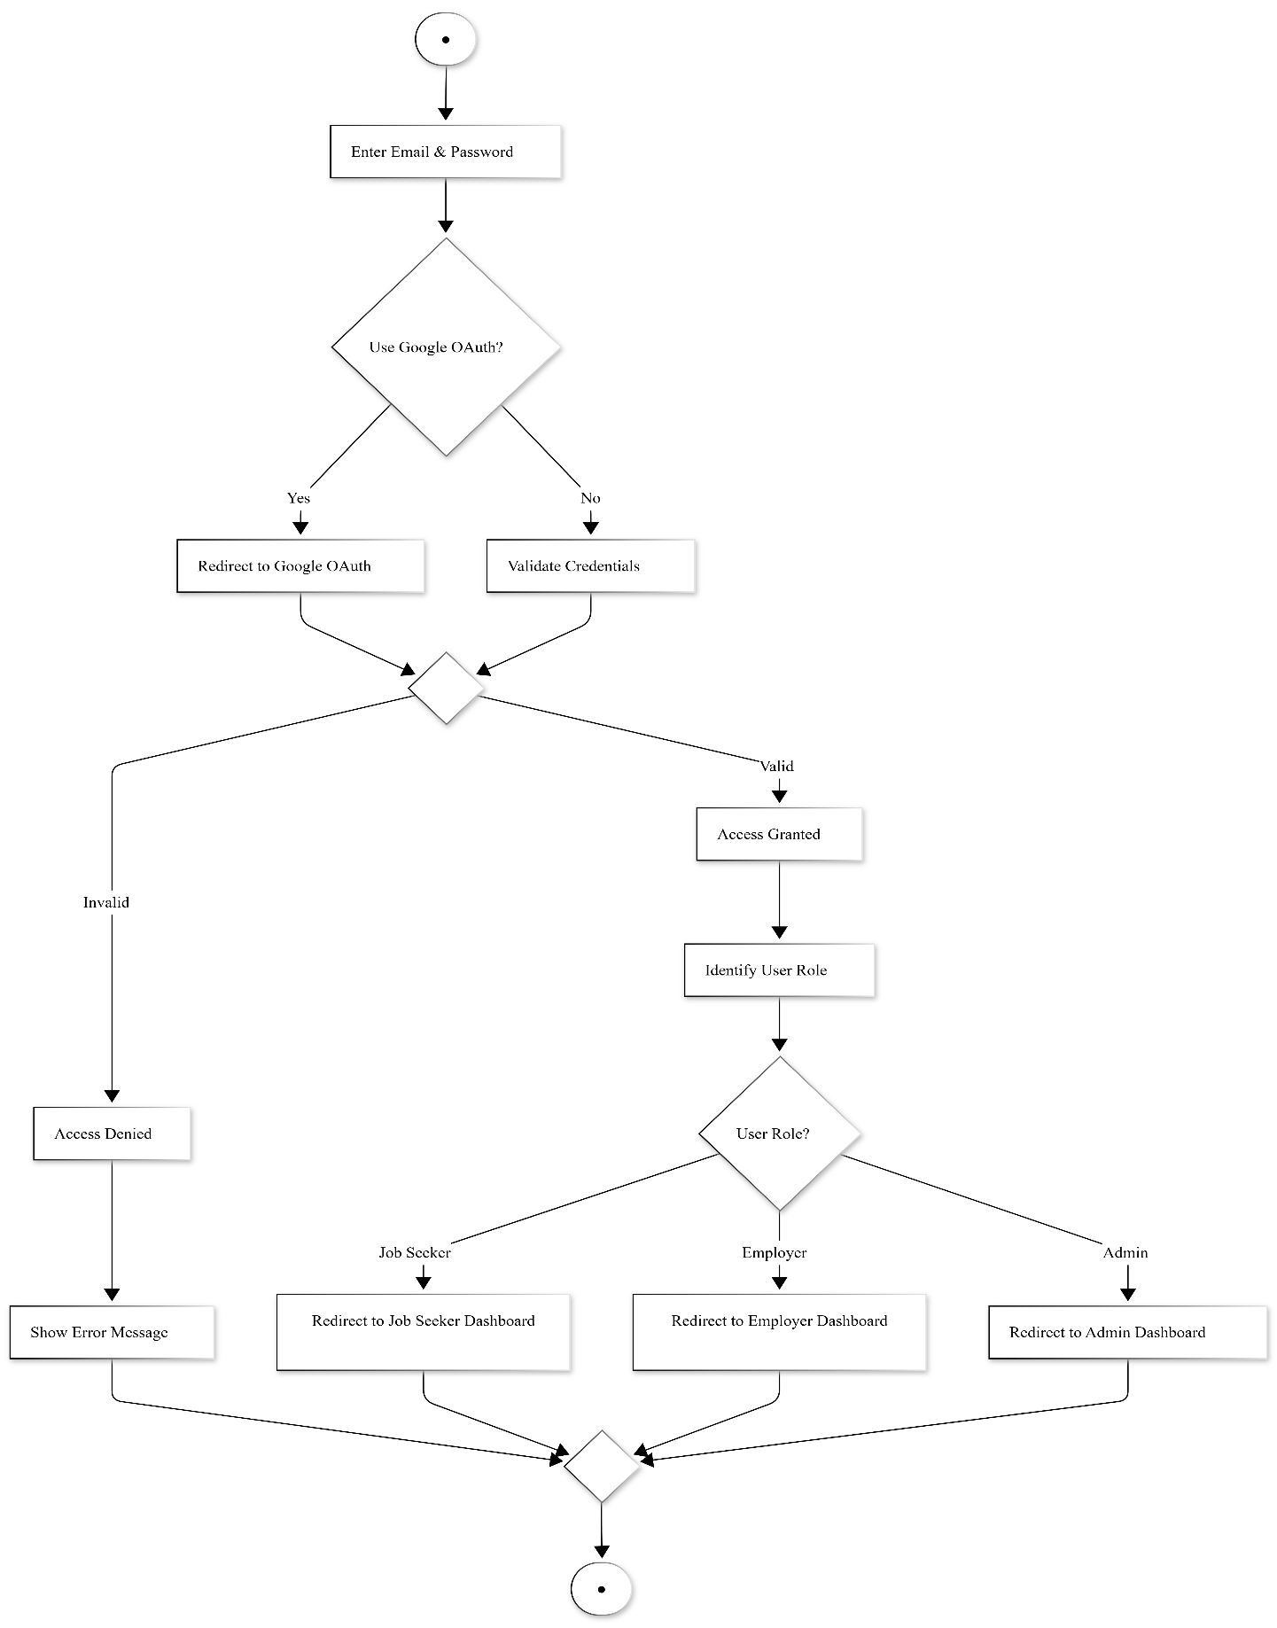

Job Application Activity Diagram

